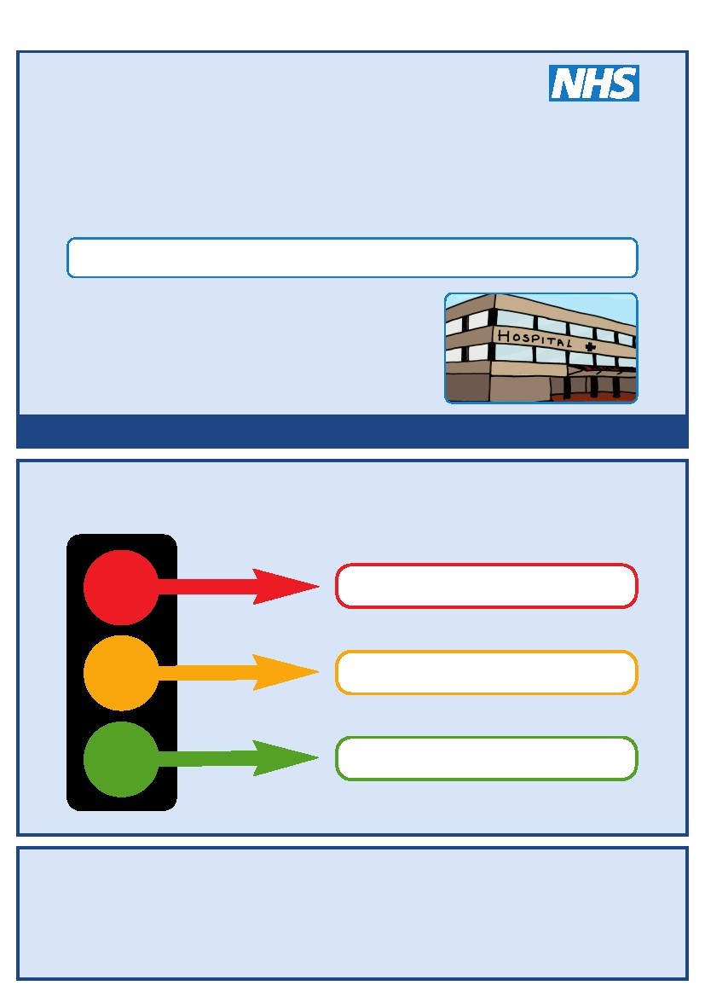
This is my
Hospital Passport
For people with learning disabilities coming into hospital
My name is:
If I have to go to hospital this book needs to
go with me, it gives hospital staff important
information about me.
It needs to hang on the end of my bed and a
copy should be put in my notes.
This passport belongs to me. Please return it when I am discharged.
Nursing and medical staff please look at my passport
before you do any interventions with me.
Things you must know about me
Things that are important to me
My likes and dislikes
Epsom and St Helier University Hospitals NHS Trust
Kingston Hospital NHS Trust
Mayday Healthcare NHS Trust
St George’s Healthcare NHS Trust
Foundation of Nursing Studies
Croydon Community Learning Disability Team
Kingston Community Learning Disability Team
Merton Team for People with Learning Disabilities
Richmond Specialist Healthcare Team (Learning Disabilities)
Sutton Learning Disabilities Team
Wandsworth Community Learning Disability Team
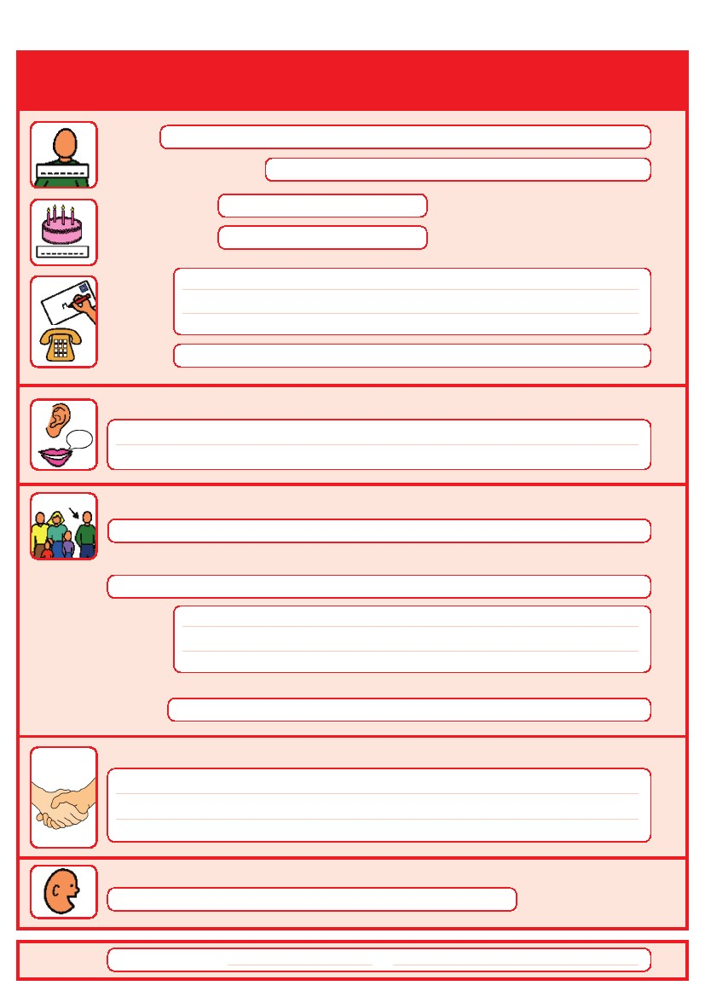
Things you must know about me
Name:
Likes to be known as:
NHS number:
Date of Birth:
Address:
Tel No:
How I communicate/What language I speak:
Family contact person, carer or other support:
Relationship e.g. Mum, Dad, Home Manager, Support Worker:
Address:
Tel No:
My support needs and who gives me the most support:
My carer speaks:
Date completed
by
1
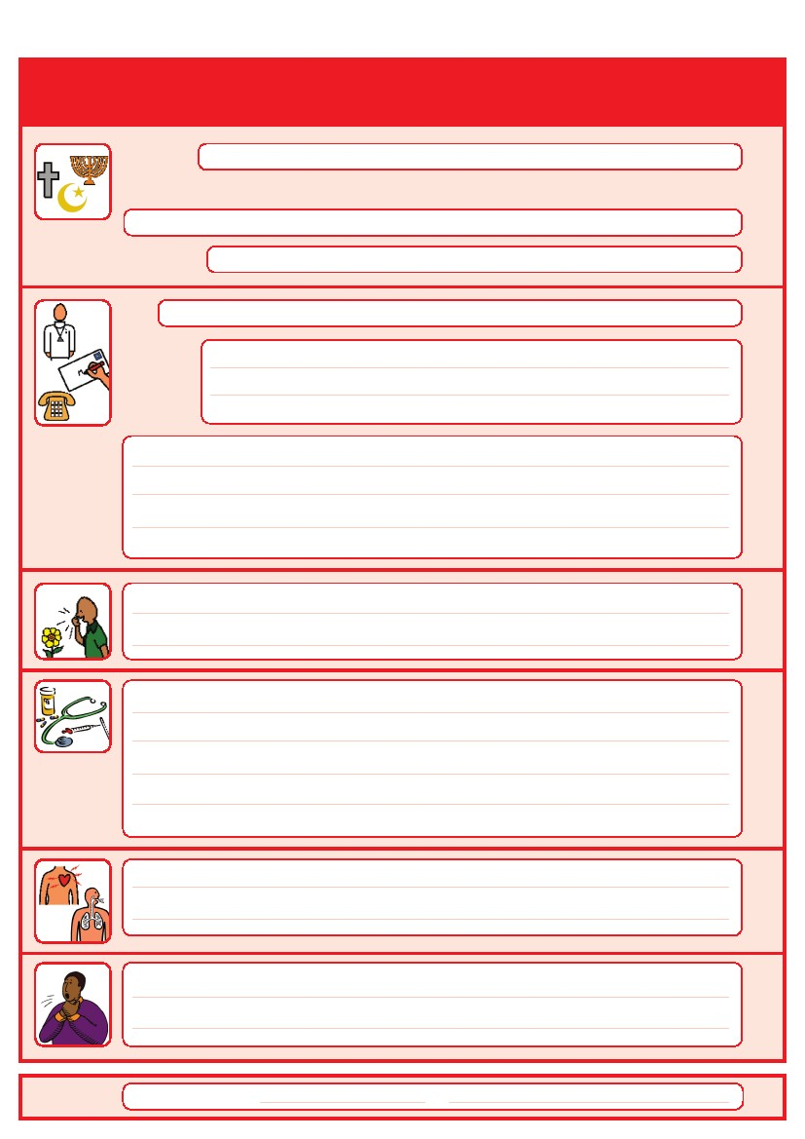
Things you must know about me
Religion:
Religious/Spiritual needs:
Ethnicity:
Address:
GP:
Tel No:
Other services/professionals involved with me:
Allergies:
Medical Interventions – how to take my blood, give injections, BP etc.
Heart
Breathing problems:
Date completed
Risk of choking, Dysphagia (eating, drinking and swallowing):
by
2
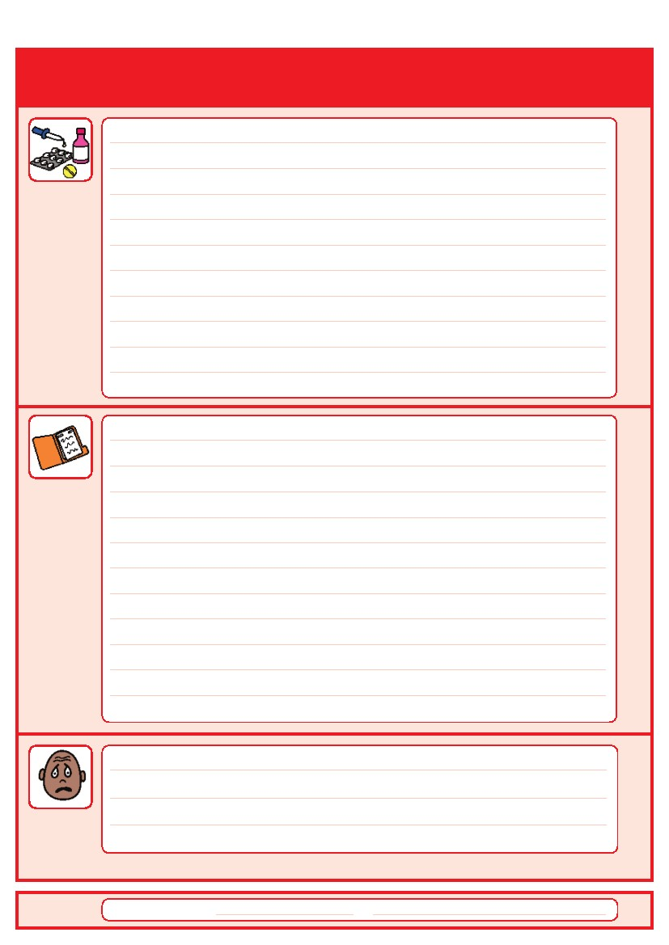
Things you must know about me
Current medication:

My medical history and treatment plan:
Date completed
What to do if I am anxious:
by
3
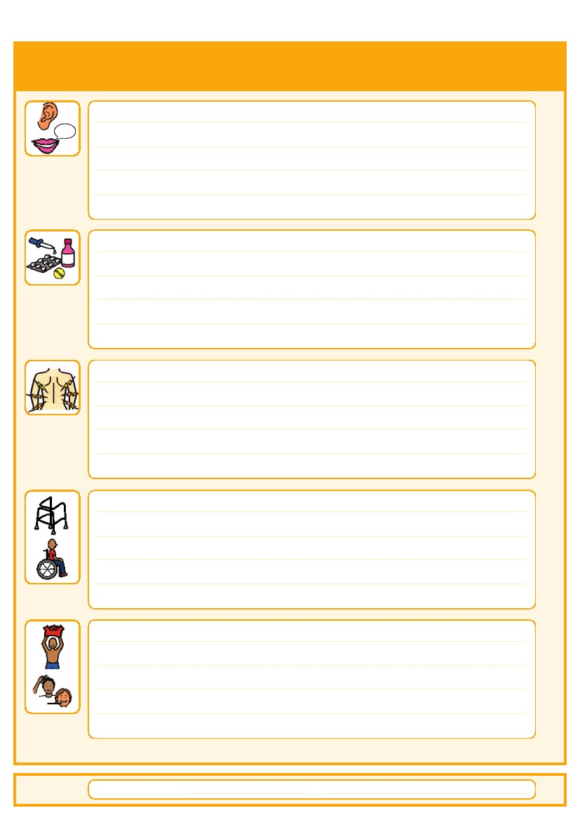
Things that are important to me
Date completed
How to communicate with me:
How I take medication: (whole tablets, crushed tablets, injections, syrup)
How you know I am in pain:
Moving around: (Posture in bed, walking aids)
Personal care: (Dressing, washing, etc)
by
4
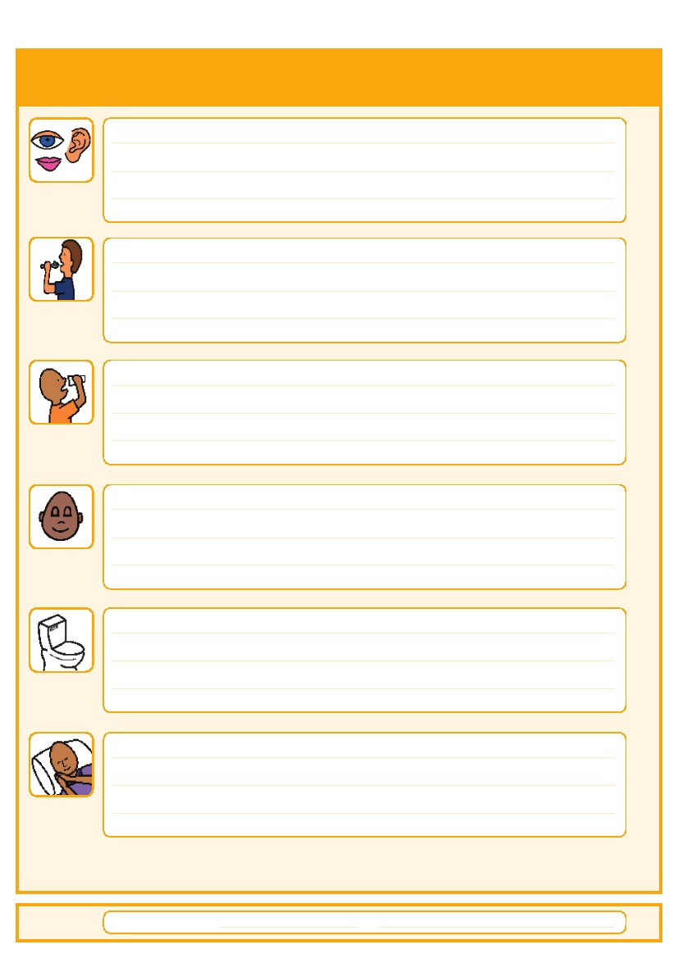
Things that are important to me
Date completed
Seeing/Hearing: (Problems with sight or hearing)
How I eat: (Food cut up, pureed, risk of choking, help with eating)
How I drink: (Drink small amounts, thickened fluids)
How I keep safe: (Bed rails, support with challenging behaviour)
How I use the toilet: (Continence aids, help to get to toilet)
Sleeping: (Sleep pattern/routine)
by
5
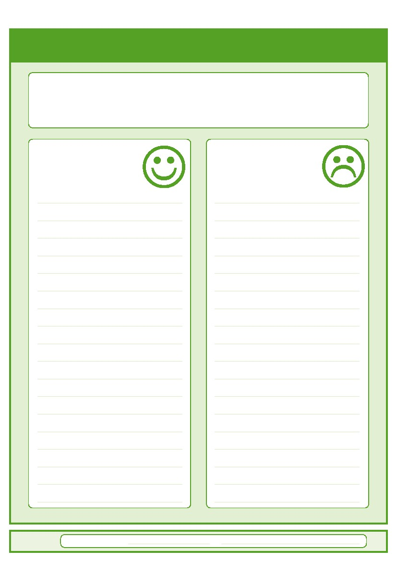
My likes and dislikes
Likes: for example - what makes me happy, things I like to do
i.e. watching TV, reading, music, routines.
Dislikes: for example - don’t shout, food I don’t like, physical touch.
Date completed
Things I like
Please do this:
Things I don’t like
Don’t do this:
by
6
7
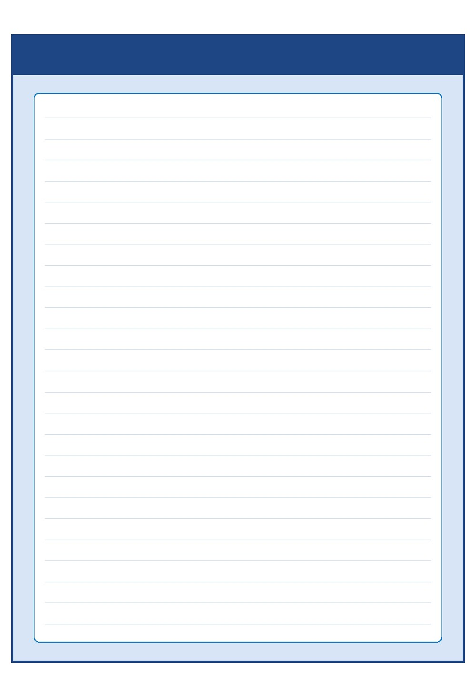 Notes


Contacts and useful websites
Community Learning Disability Teams (CLDT)
Croydon Community Learning Disability Team
(020) 8239 4441/4442
Kingston Community Learning Disability Team
(020) 8547 6558
email: cldt@rbk.kingston.gov.uk
Lambeth Community Learning Disability Team
(020) 7926 5555
Merton Team for People with Learning Disabilities
(020) 8545 4490/4545
Richmond Specialist HealthcareTeam (Learning Disabilities)
(020) 8487 5315
Sutton Learning Disabilities Team
(020) 8770 6080
Wandsworth Community Learning Disability Team
9.30am to 2pm Monday to Friday: (020) 8812 5270
Between 2-5pm and 9-9.30am: 07957 591 977
Out of hours 6pm to 9pm and weekends: (020) 8871 6000
www.easyhealth.org.uk
www.intellectualdisability.info
www.mencap.org.uk/gettingitright
8
Please contact your local community learning disability team
if you have any questions about the passport
This Hospital Passport was developed by the South West London Access to Acute Group and based
on original work by Gloucester Partnership NHS Trust.
Thank you to The Baked Bean Theatre Company, members of our community, Wandsworth
Community Learning Disability Team, members of the St Georges Access to Acute working party,
Merton CTPLD Community Nurses and the Corporate Design department at Wandsworth Council who
all inputted into the redesign of this document.
AS.42a (12.09)

